CRM APPLICATION THAT HELPS TO BOOK A VISA SLOT

1.Introduction

1.1 OVERVIEW

A visa slot management is a system that helps to track and manage the availability of Visa slot. This may be used by government agency or a visa processing centre.

1.2 PURPOSE

It helps to nurture relationships with customers for long-term sales. Although the underlying principle in CRM is not to squeeze out more profits but to make customers happy, which in turn results in product loyalty and more revenues for the business.

In this guide, you'll find more detailed answers on the fundamental aspects of CRM software.We'll discuss some of its most important benefits, potential issues you might face with the platform, and some best practices when implementing the software.

2. PROBLEM DEFINITION & DESIGN THINKING

2.1 EMPATHY MAP

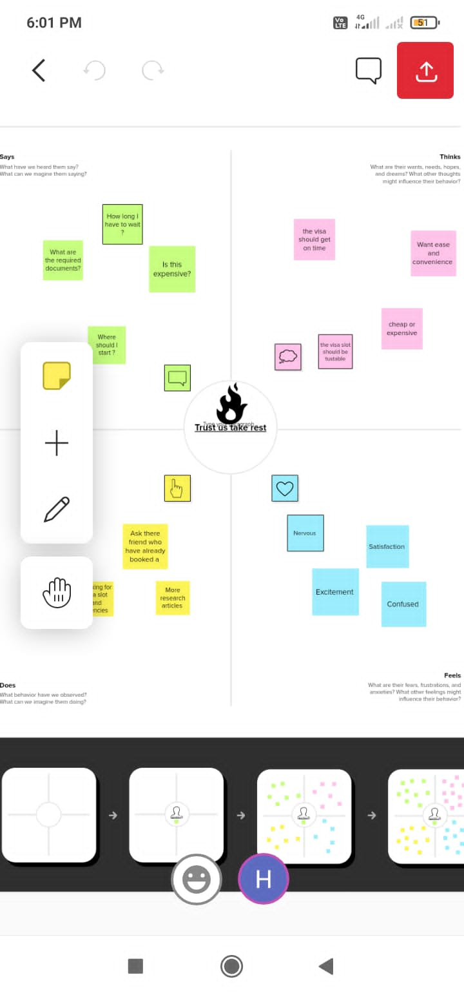

2.2 IDEATION AND BRAINSTORM

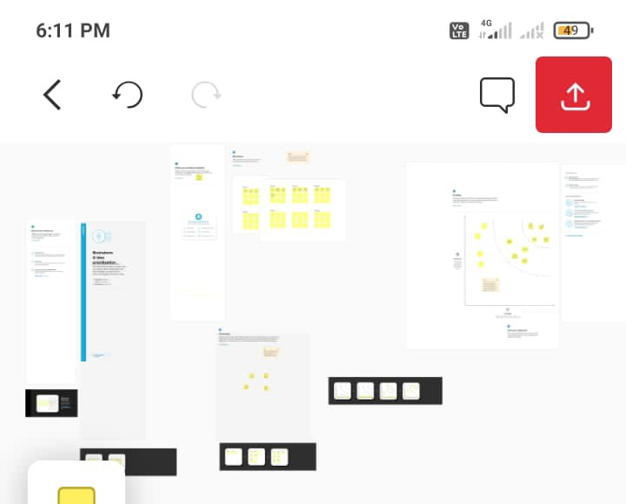

3.RESULT

|  |  |
| --- | --- |
| OBJECT NAME | FIELD IN OBJECT |
| PASSPORT | |  |  | | --- | --- | | FIELD NAME | DATA TYPE | | CONTACT NUMBER | NUMBER | | FULL NAME | TEXT | | PASSPORT NUMBER | TEXT | | PERMANENT ADDRESS | TEXT | |
| VISA SLOT | |  |  | | --- | --- | | FIELD LABEL | DATA TYPE | | LOCATION | TEXT | | TIME | TEXT | | PASSPORT NUMBER | MASTER | | VISA SLOT NUMBER | NUMBER | |
| PAYMENT | |  |  | | --- | --- | | FIELD LABEL | DATA TYPE | | PAYMENT MODE | TEXT | | CARD NUMBER | NUMBER | | TRANSACTION ID | AUTO NUMBER | | CANCEL TRANSACTION | TEXT | | VISA SLOT NUMBER | MASTER | |
| RESHEDULE/CANCEL | |  |  | | --- | --- | | FIELD LABLE | DATA TYPE | | PASSPORT NUMBER | MASTER | | LOCATION | TEXT | | TIME | TEXT | | CANCEL | TEXT | | STATUS | TEXT | |

3.2. ACTIVITY AND SCREENSHOT

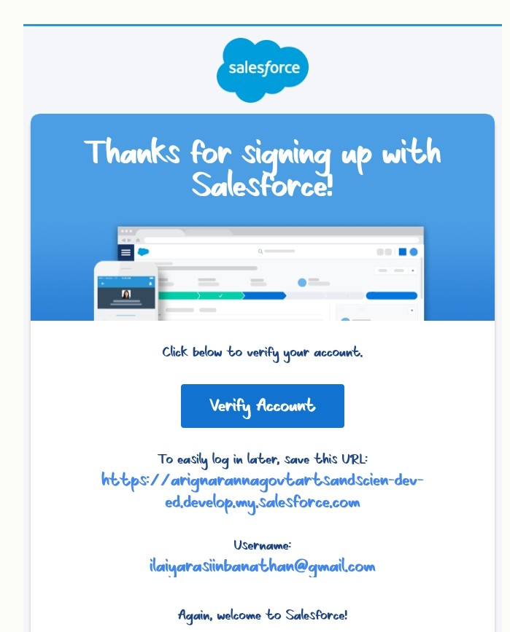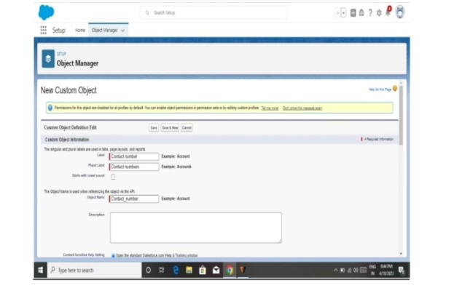 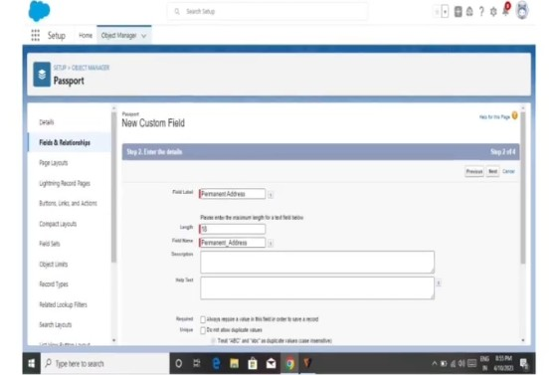 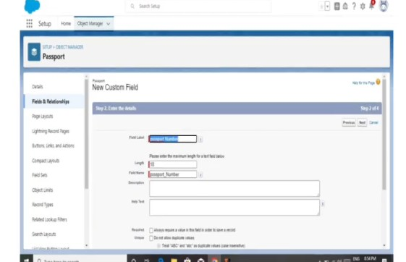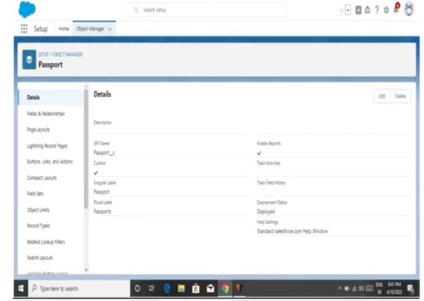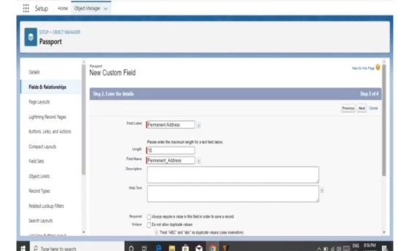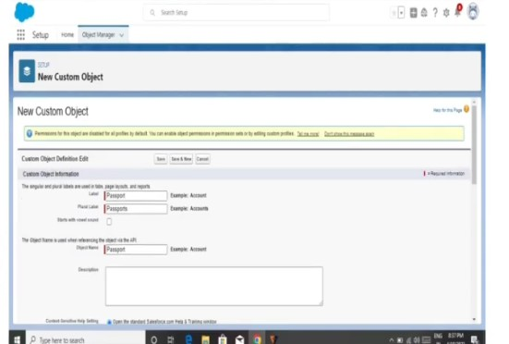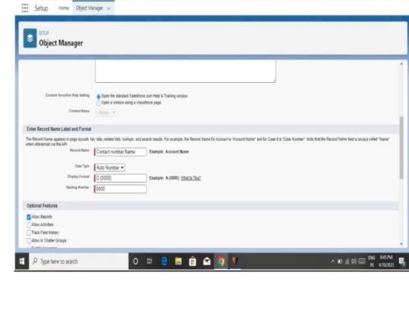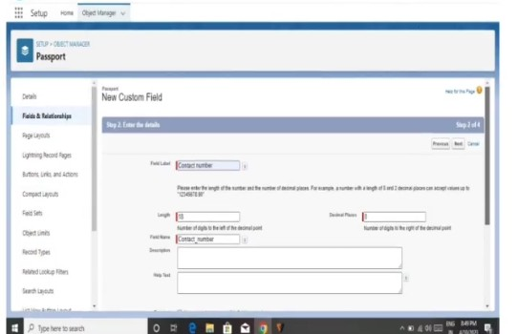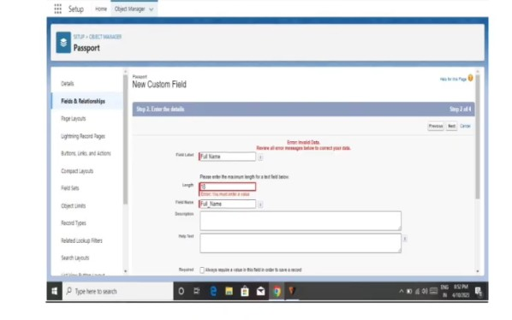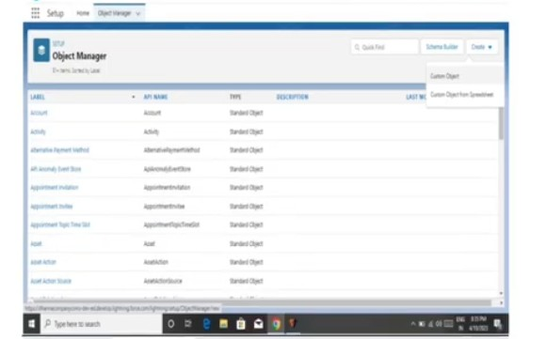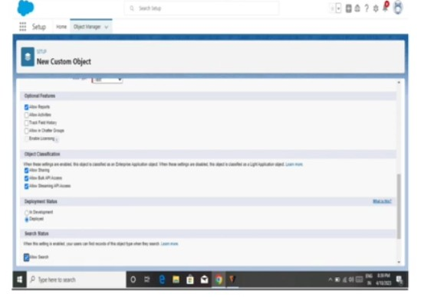

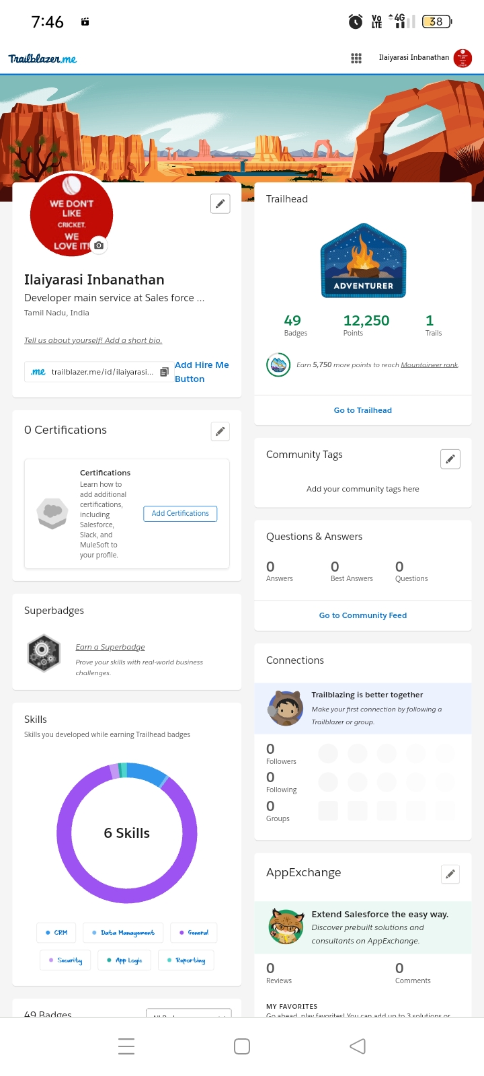

4.TRAILHEAD PROFILE PUBLIC URL:

TEAM LEADER: https://trailblazer.me/id/ilaiyarasi99

TEAM MEMBER 1: https://trailblazer.me/id/hhemavathi2

TEAM MEMBER 2:https://trailblazer.me/id/hkarunagaran

TEAM MEMBER 3: https://trailblazer.me/id/jrani64

5. ADVANTAGES

IT ALLOWS MORE EFFECTIVE AND SALES MARKETING

IT CAN SPEED UP THE CONVERSION PROCESS

IT INCREASES STAFF PRODUCTIVITY

IT HELPS WIEDLY DISPERSED TEAMS TO WORK CLOSELY

DISADVANTAGES

STAFF OVER RELIANCE ON CRMMAY DIMINISHE COUSTOMER LOYALTY

THE EXCESS INITIAL TIME AND PRODUCTIVITY COST OF IMPLEMENT

IT REQUIRES A PROCESS DRIVEN ORGANISATION

IT MAY NOT SUIT EVERY BUSINESS

6. APPLICATION

Tracking costumers

Collecting data for marketing

Planing your operation

7.CONCLUSION

COUSTOMER RELATIONSHIP MANAGEMENT ENABLES A COMPANY TO ALIGN ITS STRATEGY WITH with needs of the coustomer in order to beat meet those needs and thus ensure long term coustomer loyalty.